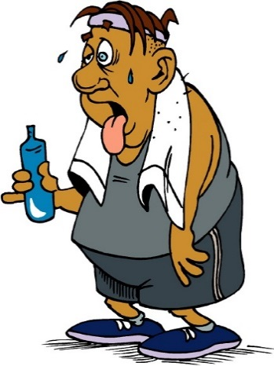****

**Physical Activity Epidemiology Lab**

MONTH July 2018

We have summer openings for new participants!!! Please, share about the study with your friends, family, neighbors, church, etc. Simply email [PAAS@IASTATE.EDU](mailto:PAAS@IASTATE.EDU) to join!

Dissertation Abstract

Nathan Meier, Ph.D.

Physical Activity and Sarcopenia in Older Adults. Conducted from 2015-2017.

The aging process is typically associated with loss of muscle mass, strength, and function. At a certain threshold, low levels of muscle mass, strength, and function are considered a disease called sarcopenia, which is associated with increased risk of falls, loss of independence, mobility issues, and mortality. Evidence suggests some of the risk factors for sarcopenia, such as sedentary lifestyle, low physical activity, bedrest, chronic disease, certain drug treatments, malnutrition, anabolic resistance, intermuscular adipose tissue infiltration, and decreased neuromuscular activation, are modifiable. Also, both the prevention and treatment of sarcopenia call for prescription of physical activity. Therefore, the overall interest of this dissertation was to investigate several of these modifiable risk factors in a group of older adults. Our purposes were to explore the cross-sectional (study 1) and longitudinal relationship (study 3) of physical activity and sarcopenia in older adults and to develop a functional Get-Up test for older adults that may be used as a screening tool (study 2) to identify individuals at higher risk of developing sarcopenia.

The goal of the first study was to investigate the cross-sectional association between physical activity, sedentary time, cardiorespiratory fitness, and muscular strength and sarcopenia in older adults. A large sample of 304 adults aged 65 years or older completed surveys and physical measurements of a wide range of health-related variables. We found that about 10% of the individuals had sarcopenia and that physical activity, sedentary time, cardiorespiratory fitness, and muscular strength were associated with sarcopenia, even when controlling for additional factors relating to the disease.

The second study established the reliability and validity of a new Get-Up test of whole-body fitness, function, and strength. We found that the test had adequate reliability across trials and over time. The validity of the test was established in a variety of ways. It was moderately to strongly correlated with existing methods for measurement of fitness, function, and strength for older adults. In a linear regression model, a combination of grip strength (strength), short physical performance battery (function), and a 400-meter walk (fitness) predicted a significant amount of the variance in the Get-up Test. Slow completion of our new Get-Up test was associated with higher prevalence of sarcopenia compared to those who completed test more quickly.

The third study explored the changes in physical activity, sedentary time, cardiorespiratory fitness, and muscular strength with changes in sarcopenia components, as well as with the hazard of developing sarcopenia over the follow-up period. Two-hundred and forty-six participants completed the follow-up measurements and did not have sarcopenia at baseline. Incidence of sarcopenia was found to be 9% over an average of 0.9 years of follow-up. The strongest predictor of developing sarcopenia was slower completion time on a fitness test compared with their baseline performance. Due to a small number of cases of sarcopenia observed at follow-up, further research is needed to explore the relationship between physical activity, sedentary time, and strength with incident sarcopenia.

This dissertation advances our understanding about the relationship between key modifiable variables and sarcopenia in older adults. Most physical activity and sarcopenia studies have not explored the impact of sedentary time, cardiorespiratory fitness, or strength and have used self-reported physical activity, which causes measurement errors, and underestimates the true benefits of physical activity by over-reporting. Often these studies failed to follow an established definition of sarcopenia or use an accurate measurement device for establishing low muscle mass. We believe these studies fill an important gap in our knowledge of the effects of physical activity on sarcopenia by adding more reliable data from stronger assessments of physical activity, sedentary time, cardiorespiratory fitness, muscular strength, and sarcopenia, as well as offering a valid and reliable potential screening tool, Get-Up test, that is appropriate for an older adult population.

Staying Hydrated

Just as winter leaves us, summer arrives. The long summer days can be hot and exhausting on the human body, so be careful to keep hydrated. Dehydration is the lack of water in your body leading to decreased function. This is a very common trend in the summer and according to the Mayo clinic men should drink 3.7 liters of water and women should drink 2.7 liters a day. According to the hydration foundation about 1 in 5 people go to the hospital for issues related to dehydration. Below are ways that you can keep hydrated in the hot summer months!

* Drink water if you are feeling hungry
* Avoid sugary drinks such as pop or lemonade
* Continue healthy eating habits
* Drink water after exercising and being outdoors
* Avoid going outside in severe heat waves
* Take breaks from the heat if you have to be outdoors

No matter what you decide to do this summer make sure that you are always hydrated!

References

Importance of Good Hydration

1. Hydration: Why it's so important. American Academy of Family Physicians. <https://familydoctor.org/athletes-the-importance-of-good-hydration/>
2. theHYDRATIONfoundation

<http://www.thehydrationfoundation.org/dehydration.html>